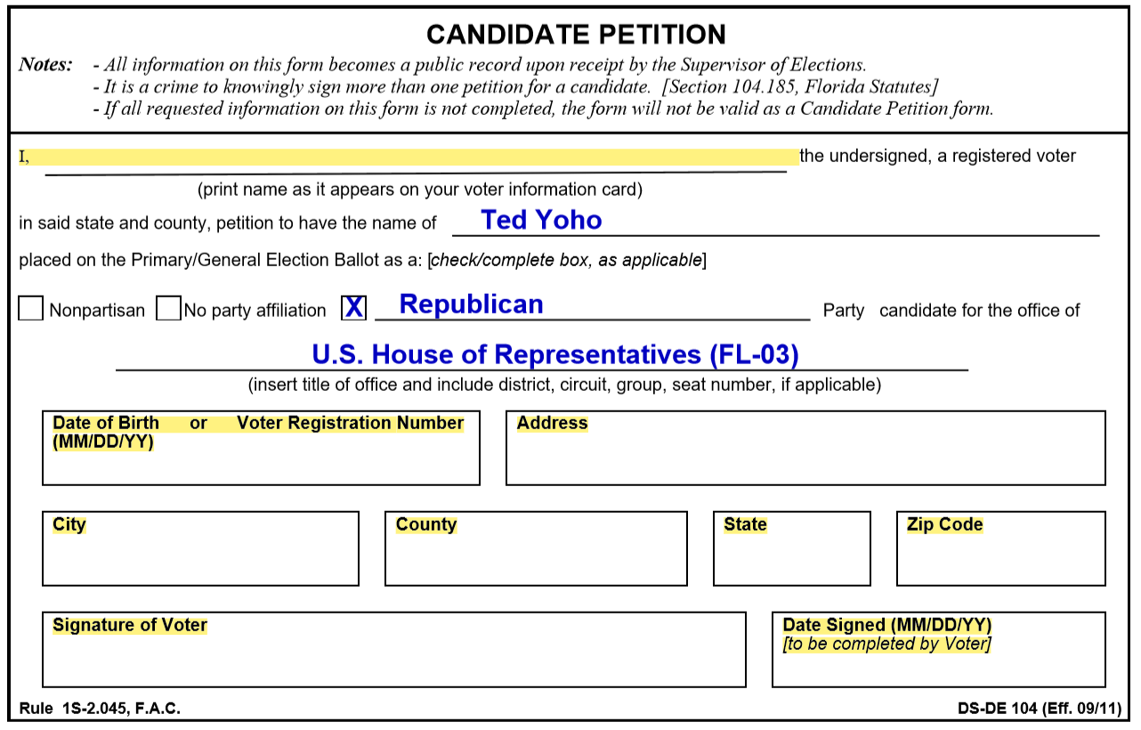

Paid for by Ted Yoho for Congress

*Help Ted Yoho get on the 2018 Ballot!*

*Complete the highlighted areas, sign the petition below and mail back to:*

Ted Yoho for Congress  
5745 SW 75th Street, #283  
Gainesville, FL 32608

Be sure to return your petition by March 29th!